* **[How to edit the Quick Launch Navigation Menu](http://www.youtube.com/watch?v=xje_i85Eheo)**

**1st way**

1. Edit->Drag any doc: at the quck launch side

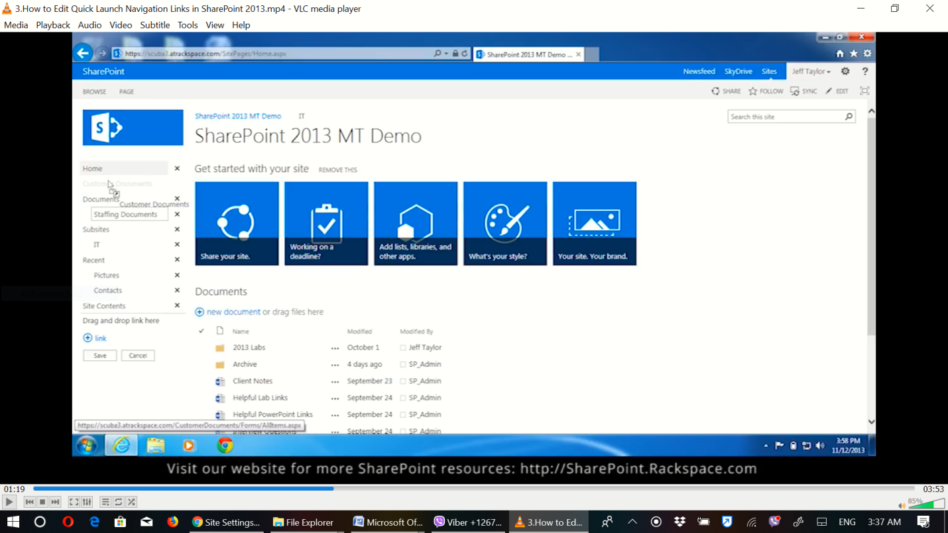

1. Link: To add link

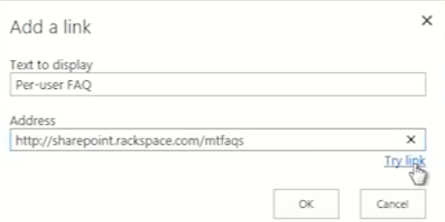

**2nd way**

1. Setting->Site setting

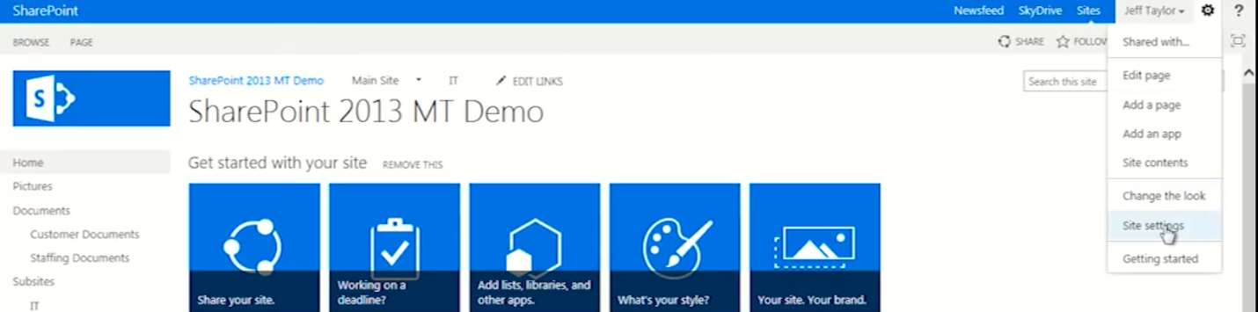

1. Site collection features

C:\Users\Nega\Desktop\paybill\PGW\s5.png

### First Activate: SharePoint Server Publishing Infrastructure

### C:\Users\Nega\Desktop\paybill\PGW\ss1.png

### 2.Setting ->Navigation

### C:\Users\Nega\Desktop\paybill\PGW\ss5.png

### Use move up and move down

